Worksheet W.A.37.1 Name __________________________________

Recursive Tree Traversals

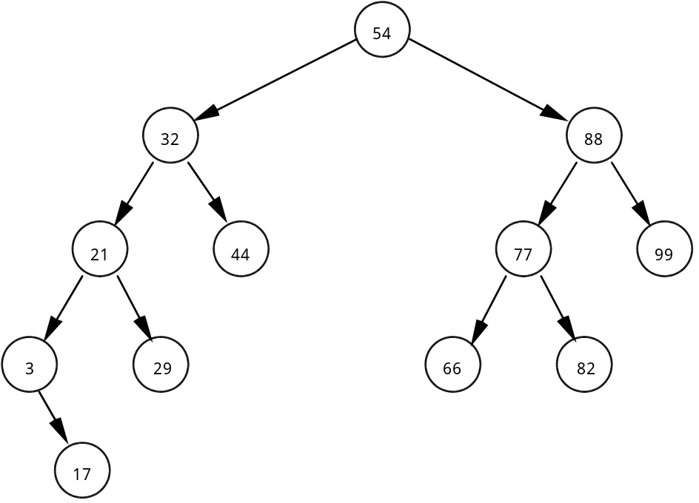

Given the above binary tree, write out the order of the following tree traversal schemes:

1. inorder: ___________________________________________________

2. preorder: __________________________________________________

3. postorder: _________________________________________________

4. Suppose this binary tree was saved to disk "inorder." What would happen when the data file was read from disk and the binary tree was rebuilt? How can this problem be solved?

5. State the order of searching an ordered binary tree. Explain your answer.

